**Noise Pollution Monitoring**

**Building the project idea:**

#include <LiquidCrystal.h> // include the LiquidCrystal library

const int micPin1 = A0; // define the pin for the first microphone

const int micPin2 = A1; // define the pin for the second microphone

const int micPin3 = A2; // define the pin for the third microphone

const int buzzerPin = 9; // define the pin for the buzzer

const int ledPin = 6; // define the pin for the LED

const int contrast = 50; // define the LCD contrast

LiquidCrystal lcd(12, 11, 5, 4, 3, 2); // initialize the LCD display

void setup() {

  pinMode(buzzerPin, OUTPUT); // set the buzzer pin as output

  pinMode(ledPin, OUTPUT); // set the LED pin as output

  lcd.begin(16, 2); // initialize the LCD display

  analogWrite(6,contrast); // set the LCD contrast

**Serial**.begin(9600); // initialize the serial monitor

}

void loop() {

  // read the values from the microphones

  int micValue1 = analogRead(micPin1);

  int micValue2 = analogRead(micPin2);

  int micValue3 = analogRead(micPin3);

  // calculate the sound levels in dB for each microphone

  float voltage1 = micValue1 * 5.0 / 1024.0; // convert the first microphone value to voltage (5V reference)

  float voltage2 = micValue2 * 5.0 / 1024.0; // convert the second microphone value to voltage (5V reference)

  float voltage3 = micValue3 * 5.0 / 1024.0; // convert the third microphone value to voltage (5V reference)

  float dB1 = 20 * log10(voltage1/0.0063); // calculate the sound level in dB for the first microphone

  float dB2 = 20 * log10(voltage2/0.0063); // calculate the sound level in dB for the second microphone

  float dB3 = 20 * log10(voltage3/0.0063); // calculate the sound level in dB for the third microphone

  // calculate the average sound level in dB for all microphones

  float averageDB = (dB1 + dB2 + dB3) / 3;

  // display the sound level on the LCD display and the serial monitor

  lcd.setCursor(0, 0); // set the cursor to the first row of the LCD display

  lcd.print("Sound Level: "); // print the text "Sound Level: " on the LCD display

  lcd.setCursor(0, 1); // set the cursor to the second row of the LCD display

  lcd.print(averageDB); // print the average sound level on the LCD display

**Serial**.print("Sound Level: "); // print the text "Sound Level: " on the serial monitor

**Serial**.println(averageDB); // print the average sound level on the serial monitor

  // control the LED and the buzzer based on the sound level

  if (averageDB > 70) { // if the sound level is higher than 70 dB

    digitalWrite(ledPin, HIGH); // turn the LED on

    tone(buzzerPin, 1000, 500); // turn the buzzer on

  } else { // if the sound level is lower than 70 dB

    digitalWrite;

  }

}

**Output:**

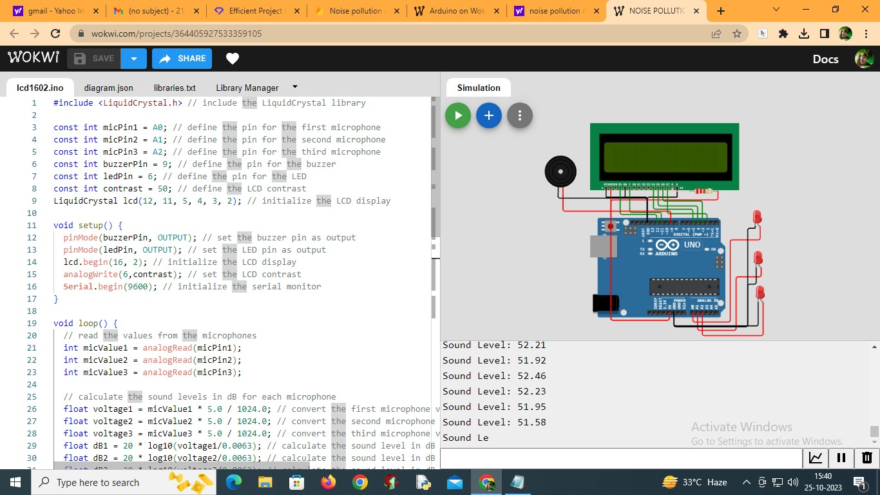

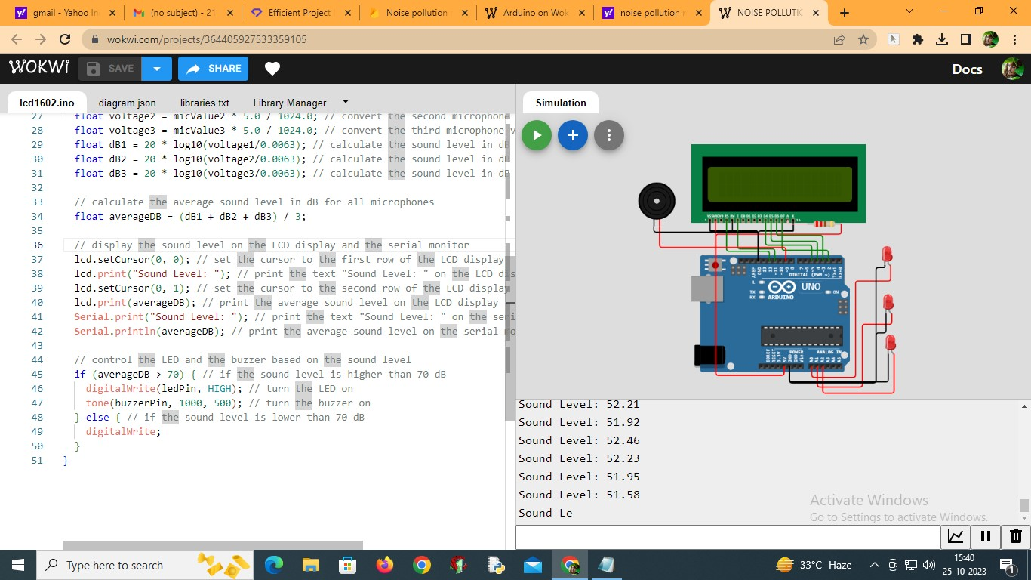

Sound Level: 52.14

Sound Level: 51.43

Sound Level: 51.41

Sound Level: 51.50

Sound Level: 51.45

Sound Level: 51.70

Sound Level: 51.80

Sound Level: 51.97

Sound Level: 52.36

Sound Level: 52.16

Sound Level: 52.24

Sound Level: 52.27

**Web Development:**

The link for web development to display real time noise level data is

[https://noisepollutionmonitoring1.mydurable.com](%20%20%20%20%20%20%20%20https://noisepollutionmonitoring1.mydurable.com)